# House Prices using Prediction Machine Learning

**Project:** House Prices Prediction



### Introduction:

**>** The real estate market is one of the most dynamic and lucrative sectors, with house prices constantly fluctuating based on various factors such as location, size, amenities, and economic conditions. Accurately predicting house prices is crucial for both buyers and sellers, as it can help make informed decisions regarding buying, selling, or investing in properties.

**>** Traditional linear regression models are often employed for house price prediction. However, they may not capture complex relationships between predictors and the target variable, leading to suboptimal predictions. In this project, we will explore advanced regression techniques to enhance the accuracy and robustness of house price prediction models.

**>** Briefly introduce the real estate market and the importance of accurate house price prediction.

Highlight the limitations of traditional linear regression models in capturing complex relationships.

**>** Emphasize the need for advanced regression techniques like Gradient Boosting and XGBoost to enhance prediction accuracy.

Content for Project Phase 2:

Consider exploring advanced regression techniques like Gradient Boosting or XGBoost for improved Prediction accuracy.

Data Source

A good data source for house price prediction using machine learning should be Accurate, Complete, Covering the geographic area of interest, Accessible.

Dataset Link: <https://www.kaggle.com/datasets/vedavyasv/usa-housing>

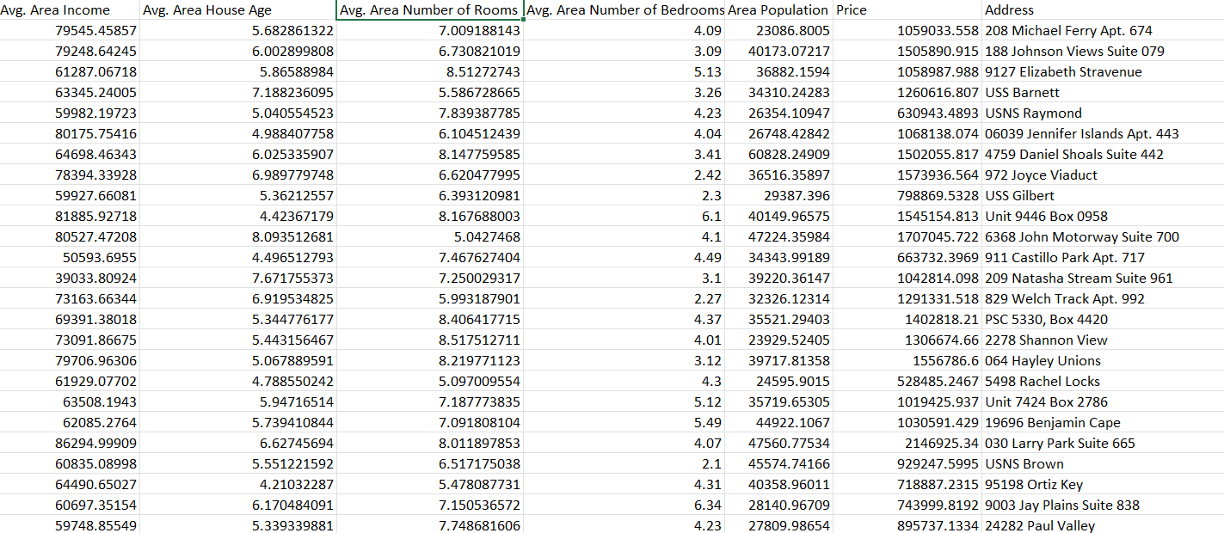

**Model Evaluation and Selection:**

. Split the dataset into training and testing sets.

. Evaluate models using appropriate metrics (e.g., Mean Absolute Error, Mean Squared

Error, R-squared) to assess their performance.

Use cross-validation techniques to tune hyperparameters and ensure model stability.

• Compare the results with traditional linear regression models to highlight

improvements.

Select the best-performing model for further analysis.

**Model Interpretability:**

Explain how to interpret feature importance from Gradient Boosting and XGBoost

models.

• Discuss the insights gained from feature importance analysis and their relevance to house price prediction.

Interpret feature importance from ensemble models like Random Forest and Gradient Boosting to understand the factors influencing house prices.

Deployment and Prediction:

• Deploy the chosen regression model to predict house prices.

• Develop a user-friendly interface for users to input property features and receive price predictions.

**Program:**

Importing Dependencies

import pandas as pd

import numpy as np

House Price Prediction

import seaborn as sns

import matplotlib.pyplot as plt

from sklearn.model_selection import train_test_split

from sklearn.preprocessing import StandardScaler

from sklearn.metrics import r2_score, mean_absolute_error, mean_squared_error

from sklearn.linear_model import LinearRegression

from sklearn.linear_model import Lasso

from sklearn.ensemble import RandomForestRegressor

from sklearn.svm import SVR

import xgboost as xg

%matplotlib inline

import warnings

warnings.filterwarnings("ignore")

/opt/conda/lib/python3.10/site-packages/scipy/_init_.py:146: User Warning: A NumPy version>=1.16.5 and <1.23.0 is required for this version of SciPy (detected version

1.23.5

warnings.warn(f" A NumPy version>={np_minversion) and <{np_maxversion}"

Loading Dataset

dataset = pd.read_csv("E:/USA_Housing.csv')

**Model 1 - Linear Regression**

**In [1]:**

model_Ir-LinearRegression()

**In [2]:**

model_lr.fit(X_train_scal, Y_train)

**Out[2]:**

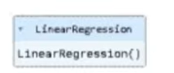

**Predicting Prices**

**In [3]:**

Prediction1 = model_Ir.predict(X_test_scal)

**Evaluation of Predicted Data**

**In [4]:**

plt.figure(figsize (12,6))

plt.plot(np.arange(len(Y_test)), Y_test, label= Actual Trend')

plt.plot(np.arange(len(Y_test)), Prediction1, label Predicted Trend')

plt.xlabel('Data')

plt.ylabel("Trend)

plt.legend()

plt.title('Actual vs Predicted')

**Out[4]:**

Text(0.5, 1.0, 'Actual vs Predicted')

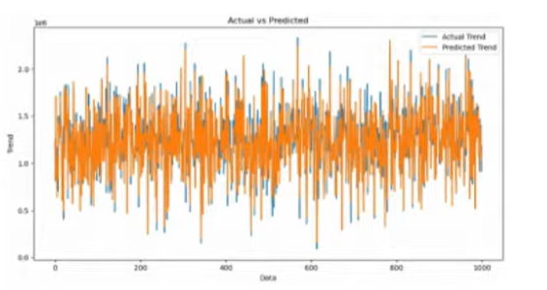

**Model 2- Support Vector Regressor**

**In [7]:**

model_svr=SVRO

**In [8]:**

model_svr.fit(X_train_scal, Y_train)

**Out[8]:**

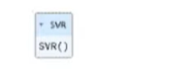

**Predicting Prices**

**In [9]:**

Prediction2= model_svr.predict(X_test_scal)

**Evaluation of Predicted Data**

**In [10]:**

plt.figure(figsize (12,6))

plt.plot(np.arange(len(Y_test)), Y_test, label Actual Trend')

plt.plot(np.arange(len(Y_test)), Prediction2, label="Predicted Trend")

plt.xlabel('Data')

plt.ylabel("Trend")

plt.legend()

plt.title('Actual vs Predicted')

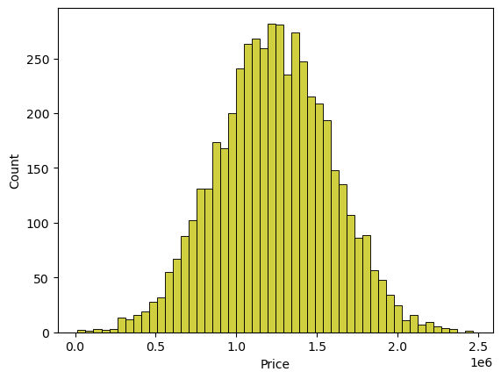

**In [18]:**

print(r2_score(Y_test, Prediction2))

print(mean absolute_error(Y_test, Prediction2))

print(mean squared_error(Y_test, Prediction2))

-0.0006222175925689744

286137.81086908665

128209033251.4034

**Model 4 - Random Forest Regressor**

**In [19]:**

model_rf = RandomForest Regressor(n_estimators-50)

**In [20]:**

model_rf.fit(X_train_scal, Y_train)

**In [24]:**

print(r2_score(Y_test, Prediction2))

print(mean_absolute_error(Y_test, Prediction2))

print(mean squared_error(Y_test, Prediction2))

**Out [24]:**

-0.0006222175925689744

286137.81086908665

128209033251,4034

**Model 5-XGboost Regressor**

**In [25]:**

model_xgxg.XGBRegresson)

**In [26]:**

model_xg.fit(X_train_scal, Y_train)

**Out[26]:**

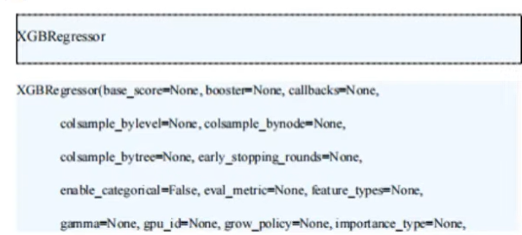

**In [30]:**

print(r2_score(Y_test, Prediction2))

print(mean absolute_error(Y_test, Prediction2))

print(mean squared_error(Y_test, Prediction2))

**Out [30]:**

-0.0006222175925689744

286137.81086908665

128209033251.4034

### Conclusion and Future Work (Phase 2):

#### Project Conclusion:

• In the Phase 2 conclusion, we will summarize the key findings and insights from the advanced regression techniques. We will reiterate the impact of these techniques on improving the accuracy and robustness of house price predictions.

• Future Work: We will discuss potential avenues for future work, such as incorporating additional data sources (e.g., real-time economic indicators), exploring deep learning models for prediction, or expanding the project into a web application with more features and interactivity.